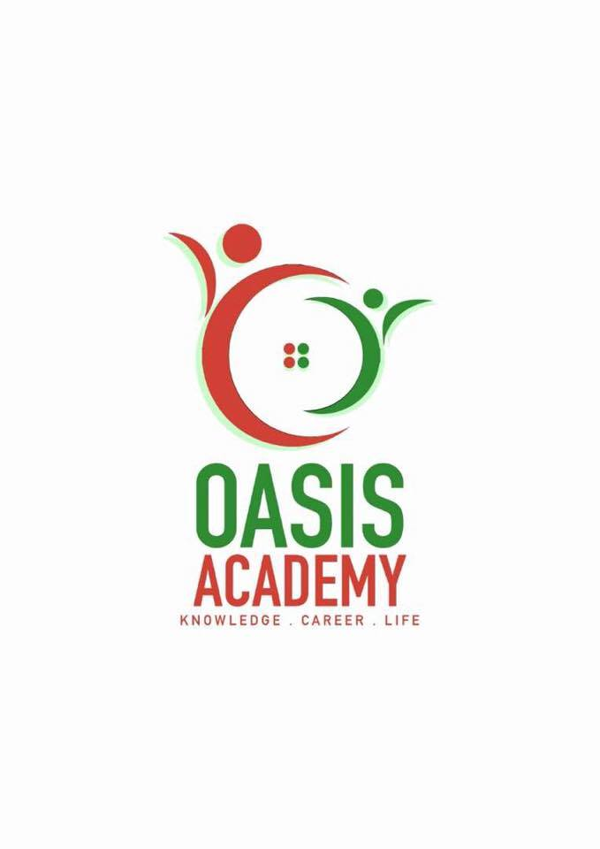

**Name:** Eragunathan A/L Subramaniam

**Login ID**: eragunathan@oasis-potral.com

**Course title:** Essentials of Human Resource

**Subject Code**: BHM01

Submitted date: 4/6/2017

**Table of Contents**

|  |  |  |
| --- | --- | --- |
| No | Details | Page |
| 1 | Executive Summary | 3 |
| 2 | Introduction | 4 |
| 3 | Part 1 | 5-7 |
|  | Part 2 | 8-12 |
|  | Part 3 | 13-15 |
|  | Part 4 | 16-18 |
| 4 | Conclusion | 19 |
| 5 | References | 20 |

**Executive summary**

The inspiration driving doing this errand is to give learning or to get more data of HRM part in the affiliation. In any case, we discussed importance of HR, reliably we furthermore inspected on the concentrations noteworthy activities, which are payrolls, benefits, enlistment, get ready and prosperity and security moreover. this are the real exercises of the HR operation.

By then we illuminated a little significance about re-outlining work handle for improved productivity; startling workforce; mass customization; decentralized work goals; laborer's incorporation.

Moreover, in the third part we have elucidated about the payrolls; benefits; enrollment; get ready and besides prosperity and security in detail. As a last touch, we similarly communicated a couple concentrates on legitimate structures.

**Introduction**

The goal of the task is to having the capacity to comprehend tourism and neighborliness better and in addition knowing the fundamentals in tourism and accommodation operations. Human asset incorporates everything related to the business specialist relationship and is about supporting and managing the affiliation's connected techniques. It's seen as an inside business work fundamental to the affiliation's reasonable operation.. Human asset operation and directs work force activity to guarantee exact status and record keeping for business record. HR operation arranges, works together and underpins scholarly issue, the finance office and offices and unit crosswise over grounds to guarantee convenient and exact handling of records related with every workforce and staff part's business status. A portion of the administration HR operation does would be process business activity frames, issues work contracts, support and aides office agents with culminations of structures and propel work activity ask for endorsement.

Question 1

Human Resource stands for HR, a division of an association that arrangements with worker related issues. HR operations allude to administrations gave by a HR division to business operations. HR operations, or operational HR administrations, incorporate regulatory administrations, enrollment, work investigation, and worker relationship administration. These HR practices are set up to bolster administration and staff in their everyday business exercises, and are critical to meet an association's objective. Private companies that needn't bother with undeniable HR operations regularly like to outsource the required administrations. Huge organizations in which the extent of HR administrations is tremendous support in-house HR operations. The major activities played by HR are employment concerns, morale and mentoring, legalities , strategic and safety and health..

Employment concerns. The business takes into account individuals, and fruitful accommodation wanders make it a need to expertly serve their visitors. A part of the HR office in this attempt is to enroll great workers and prepare them to wind up plainly extraordinary representatives who appreciate serving others, accomplishing an abnormal state of client administration. The HR division's part additionally includes pay and advantages organization. This incorporates ensuring wages and advantages are aggressive with other comparative eateries or lodgings. In the event that an accommodation association is a "union shop," the HR office's part incorporates watching out for wages, and additionally checking the division of work among offices to prepare for supervisors or staff over-or under-venturing compensation and work necessities set by the union.

Morale and mentoring. The HR division is a champion of worker confidence, making representative projects that will permit the proceeded with development of an unrivaled level of resolve. The HR office additionally cultivates worker improvement through tutoring both administration and line staff, and controlling them through the different strides to completing their objectives. HR may make particular arrangements for staff individuals to take after, commending victories and giving guidance for zones requiring consideration.

Legalities. Shielding representatives from unfriendly business hones, and defending the association from worker suit is a profound capable of the HR division. In view of high business levels, friendliness associations may utilize excessively few or an excessive number of staff individuals. Both conditions can some of the time make circumstances where supervisors coincidentally plan representatives to work excessively numerous hours per move or an excessive number of sequential days, causing a circumstance outside the points of confinement of consistence with current work law. A huge and different staff may likewise make open doors for badgering or different issues requiring intercession by the HR office. HR staff is relied upon to know work law and to guarantee the association clings to the law.

Strategic. In its part as human supervisor, the HR office is a key join forces with the accommodation association. As the association extends or gets, the HR division is innately in charge of giving work force to development and furthermore to implement scaling back. Keeping control of the expenses related with business, incorporating those associated with wages and advantages, is a key and essential part of the HR division. Without a doubt, the whole authoritative structure of the cordiality association may depend upon the HR office to guarantee smooth business work.

Safety and health. Working condition prosperity is a basic segment. Under the Word related Security and Prosperity Show of 1970, organizations have a promise to give an ensured working environment to agents. One of the rule components of HR is to reinforce working condition security get ready and keep up administratively requested logs for workplace harm and loss uncovering. Additionally, HR security and risk aces as often as possible work personally with HR benefits experts to manage the association's authority’s compensation issues.

Question 2

**Globalization and its suggestions. Business today doesn't have national limits – it stretches the world over. The ascent of multinational partnerships puts new necessities on human asset administrators. The HR office needs to guarantee that the suitable blend of representatives as far as learning, aptitudes and social flexibility is accessible to deal with worldwide assignments. With a specific end goal to meet this objective, the associations must prepare people to address the difficulties of globalization. The representatives must have working information of the dialect and culture (regarding values, ethics, traditions and laws) of the host nation. Human Resource Management (HRM) should likewise create instruments that will help multicultural people cooperate. As foundation, dialect, custom or age contrasts turn out to be more common, there are signs that representative clash will increment. HRM would be required to prepare administration to be more adaptable in its practices. Since tomorrow's specialists will come in various hues, `nationalities et cetera, chiefs will be required to alter their way of living. This will require directors being prepared to perceive contrasts in laborers and to acknowledge and even commend these distinctions.**

Work-compel Diversity. In the past HRM was significantly less difficult in light of the fact that our work compel was strikingly homogeneous. Today's work constrain includes individuals of various sex, age, social class sexual introduction, values, identity qualities, ethnicity, religion, instruction, dialect, physical appearance, conjugal status, way of life, convictions, belief systems and foundation attributes, for example, geographic starting point, residency with the association, and financial status and the rundown could go on. Assorted qualities is basically connected to the association's key bearing. Where differing qualities thrives, the potential advantages from better innovativeness and basic leadership and more prominent development can be accumulated to help expand association's intensity. One methods for accomplishing that is through the association's advantages bundle. This incorporates HRM offerings that fall under the heading of the family benevolent association. A family inviting association is one that has adaptable work routines and gives such worker advantages, for example, youngster mind. Notwithstanding the assorted qualities brought by sexual orientation and nationality, HRM must know about the age contrasts that exist in today's work drive. HRM must prepare individuals of various age gatherings to viably oversee and to manage each other and to regard the differing qualities of perspectives that each offers. In circumstances like these a participative approach appears to work better

.

**Changing ability necessities. Enrolling and creating gifted work is essential for any organization worried about aggressiveness, profitability, quality and dealing with an assorted work constrain viably. Expertise insufficiencies convert into critical misfortunes for the association regarding low quality work and lower efficiency, increment in representative mischances and client objections. Since a developing number of employments will require more instruction and larger amounts of dialect than current ones, HRM experts and authorities should impart this to teachers and group pioneers and so on. Vital human asset arranging should precisely measure the ability lacks and deficiencies. HRM division should devise appropriate preparing and here and now projects to connect the expertise holes and inadequacies.**

**Corporate scaling down. At whatever point an association endeavors to delayer, it is endeavoring to make more prominent productivity. The introduce of scaling back is to lessen the quantity of laborers utilized by the association. HRM division has a critical part to play in cutting back. HRM individuals must guarantee that appropriate correspondence must happen amid this time. They should limit the negative impacts of bits of gossip and guarantee that people are kept educated with verifiable information. HRM should likewise manage real cutback. HRM profundity is critical to the cutting back talks that need to occur.**

**Constant changes of programs. Constant change programs concentrate on the long haul prosperity of the association. It is a procedure whereby an association concentrates on quality and manufactures a superior establishment to serve its clients. This frequently includes a companywide activity to enhance quality and efficiency. The organization changes its operations to concentrate on the client and to include laborers in matters influencing them. Organizations endeavor to enhance everything that they do, from contracting quality individuals, to managerial paper preparing, to addressing client needs.**

**Sadly, such activities are not something that can be effectively executed, nor directed down through the many levels in an association. Or maybe, they resemble an association wide improvement handle and the procedure must be acknowledged and bolstered by top administration and driven by communitarian endeavors, all through each section in the association. HRM assumes a vital part in the execution of ceaseless change programs. At whatever point an association sets out on any change exertion, it is bringing change into the association. Now association advancement activities command. In particular, HRM must get ready people for the change. This requires clear and broad interchanges of why the change will happen, what is not out of the ordinary and what impact it will have on workers.**

Question 3

Employment concerns. In a unionized working environment, the specialist and work relations components of HR may be solidified and dealt with by one ace or be totally separate limits supervised by two HR experts with specific ability in each zone. Delegate relations is the HR prepare stressed with invigorating the business specialist relationship through measuring work satisfaction, laborer engagement and settling working condition strife. Work relations limits may join making organization response to union dealing with campaigns, masterminding total trading affirmations and rendering understandings of laborer's association contract issues.

Morale and mentoring. Bosses must furnish representatives with the instruments fundamental for their prosperity which, as a rule, implies giving new workers broad introduction preparing to help them move into another hierarchical culture. Numerous HR offices likewise give initiative preparing and expert advancement. Administration preparing might be required of recently contracted and advanced directors and supervisors on themes, for example, execution administration and how to deal with representative relations matters at the division level. Proficient improvement openings are for workers searching for special open doors or representatives who need to accomplish individual objectives, for example, completing a higher education. Projects, for example, educational cost help and educational cost repayment programs frequently are inside the domain of the HR preparing and improvement range.

Legalities. Consistence with work and business laws is an essential HR work. Resistance can realize workplace disagreements in light of uncalled for business practices, unsafe working conditions and general frustration with working conditions that can impact productivity and in the long run. HR staff must think about government and state business laws, for instance, Title VII of the Social equity Act, the Sensible Work Standards Act, the National Work Relations Act and various distinctive norms and controls.

Safety and health. Businesses have a commitment to give a protected workplace to representatives. One of the principle elements of HR is to bolster working environment security preparing and keep up governmentally commanded logs for work environment harm and casualty detailing. Likewise, HR security and hazard authorities frequently work intimately with HR benefits experts to deal with the organization's specialists remuneration issues

Strategic. Reinforcing the business worker relationship is the vital part of a HR director. Be that as it may, there's something else under the surface the eye to doing this. HR supervisors plan workforce methodology and decide the functional processes important to meet hierarchical objectives.

Question 4

Organizational behavior relies on upon the audit why people bear on as they do in different situation in an affiliation. In the warmth business the laborers direct ascents as easygoing or formal lead of the individual and social affairs. Here each one of the delegates work towards improving various leveled lead. Certainly, there are differentiations between individual when they are set in practically identical conditions whereby, each one of the all inclusive community don't act alike. There are certain focal surfaces shrouded the direct surprisingly that can be recognized and after that get changed to reflect particular differentiations. Various leveled structure is a system that includes express and certain institutional rules and courses of action proposed to outline how diverse capacity parts and obligations are assigned, controlled and encouraged. Hierarchical conduct is isolated into administrative conduct, singular conduct, bunch conduct and shopper conduct. This practices depend on the specific's mentality, connection and workplace.

At its biggest sum, a progressive structure is either united or decentralized. By and large, affiliations have been sorted out with concentrated expert and a portrayed pecking order of administration. The military, for example, is an affiliation eminent for its significantly thought structure, with a long and specific pecking request of supervisors and subordinates. In any case, there has been a climb in decentralized affiliations, much the same as the case with various development new organizations. This empowers the associations to remain fast, able and flexible, with for all intents and purposes each laborer tolerating an irregular condition of individual office.

Four sorts of fundamental various leveled structures are executed in this present reality. The in any case, and most ordinary, is a helpful structure. This is in like manner implied as a bureaucratic legitimate structure and isolates an association in perspective of the specialization of its workforce. Most little to-medium measured associations execute an utilitarian structure. Separating the firm into workplaces involving promoting, arrangements and operations is the exhibition of using a bureaucratic definitive structure.

The second sort is essential among generous associations with various strength units. Called the divisional or multi-divisional structure, an association that uses this procedure structures its organization assemble in light of the things, exercises or reinforcements they work. A nice instance of this structure is Johnson and Johnson. With a substantial number of things and lines of business, the association structures itself so every forte unit fills in as its own specific association with its own particular pioneer.

Boring, a fresher structure, is the third sort and is used among various new organizations. As the name proposes, it rectifies the pecking request and chain of command of administration and gives its specialists an impressive measure of self-run the show. Associations that use this kind of structure have a quick of use.

The fourth and last progressive structure is a system structure. It is moreover the most dumbfounding and the base used. This structure systems laborers transversely over different managers, divisions or workplaces. A laborer working for a matrixed association, for example, may have commitments in both arrangements and customer advantage.

**Conclusion**

Human Asset Administration concentrates on coordinating the requirements of the business with the necessities and improvement of representatives. Landing area relies on upon its kin in light of the fact that their aptitudes add to accomplishing its business destinations. More or less, Human asset operations assumes a tremendous part on improving the organization's execution whereby, HR oversees and handles the representatives an appropriate administration by the HR division can prompt incredible achievement.

**References**

* <http://www.icmrindia.org/courseware/Intro%20to%20Hrm/Human%20Resource%20Management.htm>
* <http://yourbusiness.azcentral.com/role-human-resource-department-hospitality-organization-8084.html>
* <http://hotelexecutive.com/business_review/3009/hotel-human-resources-five-greatest-challenges-and-what-to-do-about-them>
* <http://www.whatishumanresource.com/Human-Resource-Management-functions>
* <https://www.cipd.co.uk/knowledge/strategy/hr>
* <https://hrtrendinstitute.com/2016/11/23/hr_trends_2017/>
* <https://www.fastcompany.com/3066976/the-top-five-hr-trends-for-2017>
* <https://www.humanresourcestoday.com/hr-trends/>
* <https://www.ingentis.com/orgmanager/orgchartsoftware/org-chart-software/>